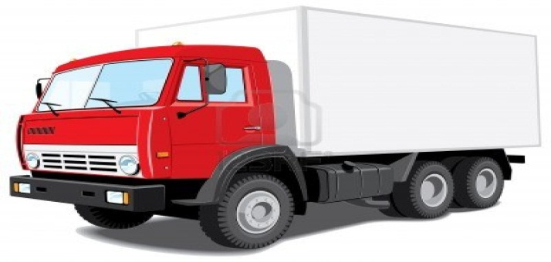
LORRY
A big land trasportation used to carry heavy loads.

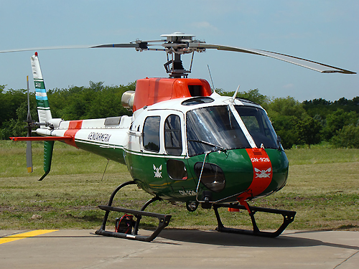
HELICOPTER
An air transportation used to carry people or things on inestable areas.

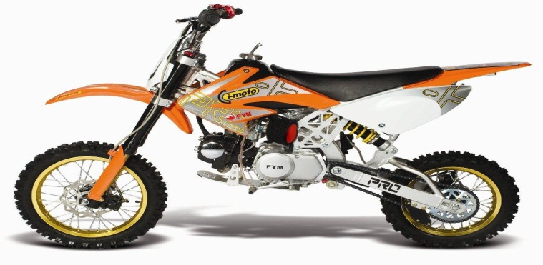
MOTORCYCLE
A two wheels land transportation with enginge used to deliever small loads or Couriers.

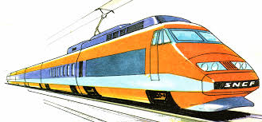
TRAIN
A long land transportation with wagons used to carry heavy loads or people.

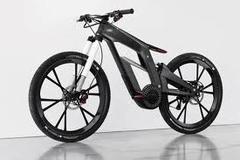
BIKE
A two wheels land transportation used to deliever small objects or Couriers.

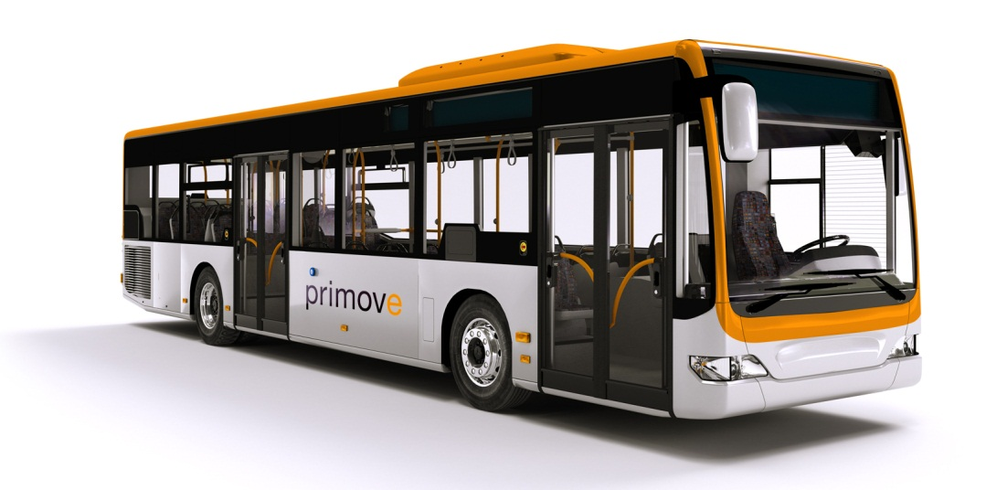
BUS
A land trasport to carry many people to short or long distances

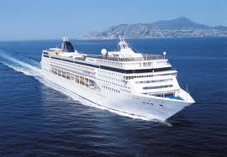
SHIP
A big water trasportation used to carry a lot of people or heavy things on the ocean
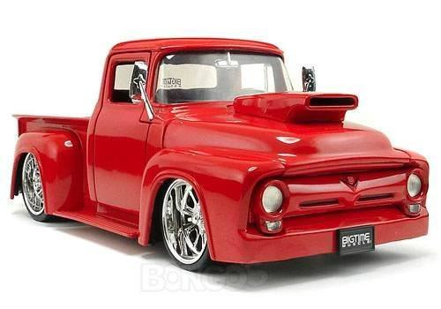
CAR

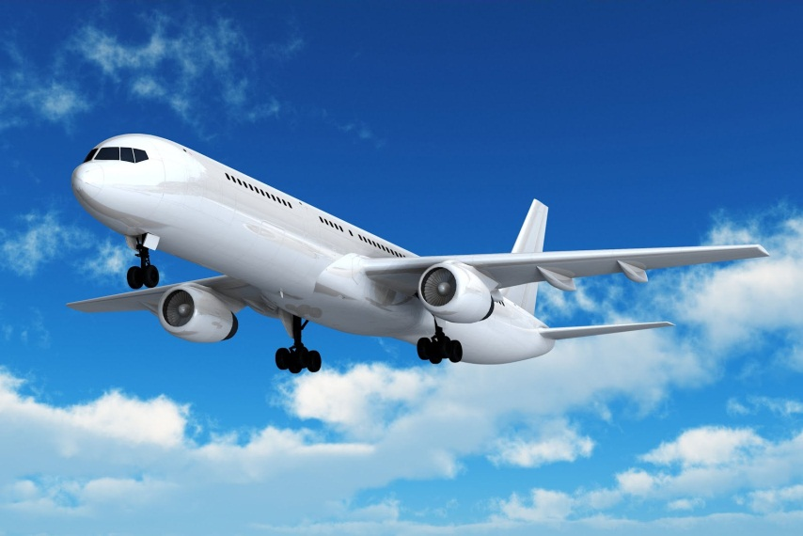
PLANE
BY: Jaime Andrés Pérez – Marketing AM

